Govt. Hnahthial College
Annual report of the physical infrastructure and learning resources for the year 2023-2024

Sl. No | Name of Infrastructure | No. of infrastructure | Description | Photograph
1 | Classrooms (overall) and attached infrastructure | 14 rooms | The college has 13 classrooms and 1 seminar hall with adequate seatings, lighting, cooling facilities and white boards to impart classroom learning, teaching as well as group discussions and presentations.  Total number of seats – 239 ( customised benches with attached desks)  No. of Lights in all classrooms – 79 (LED and standard tube)  No. of cooling systems (fans) – 44 (wall mount and ceiling fans)  No of lecterns – 10  No.of white boards - 14 | 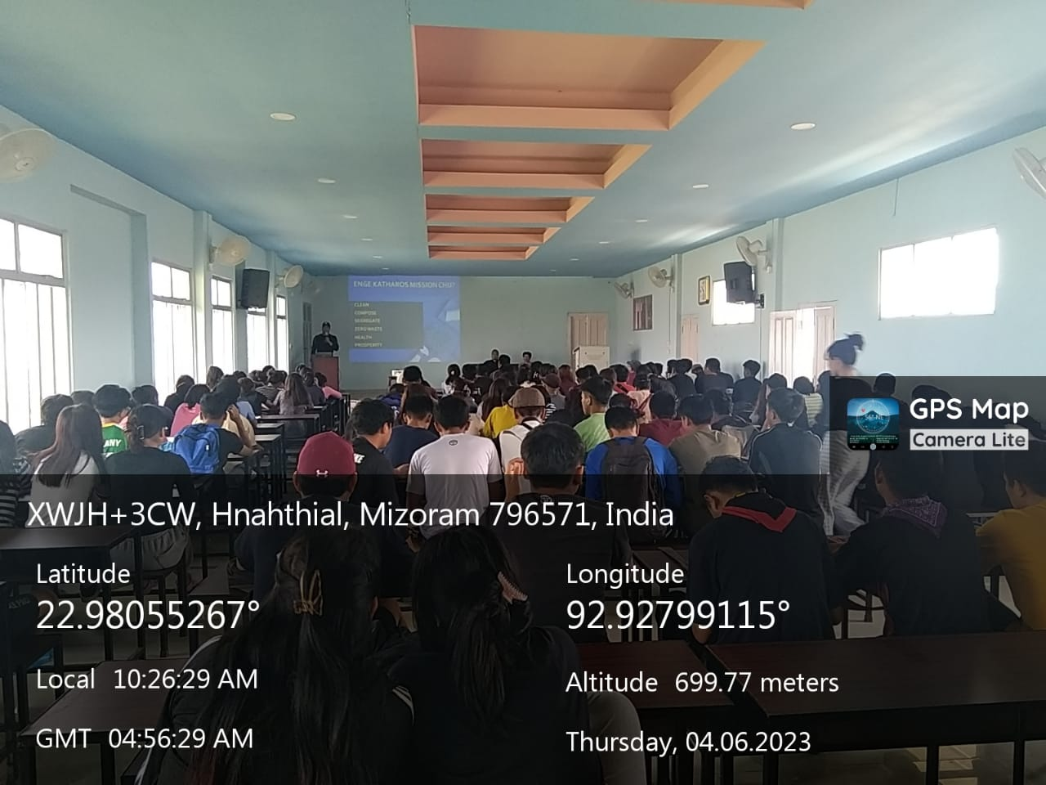  Seminar Hall  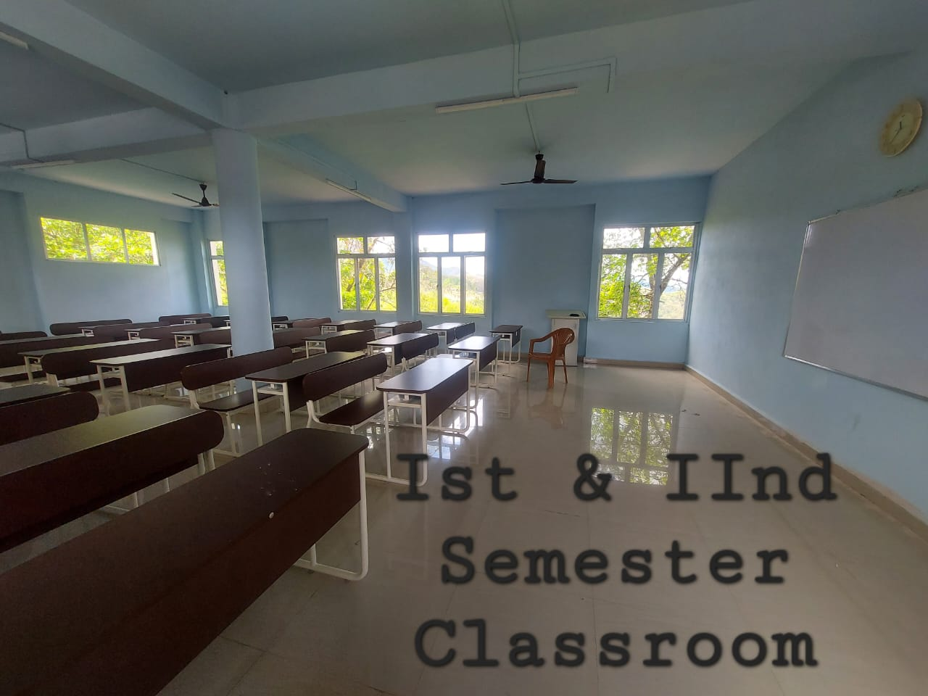  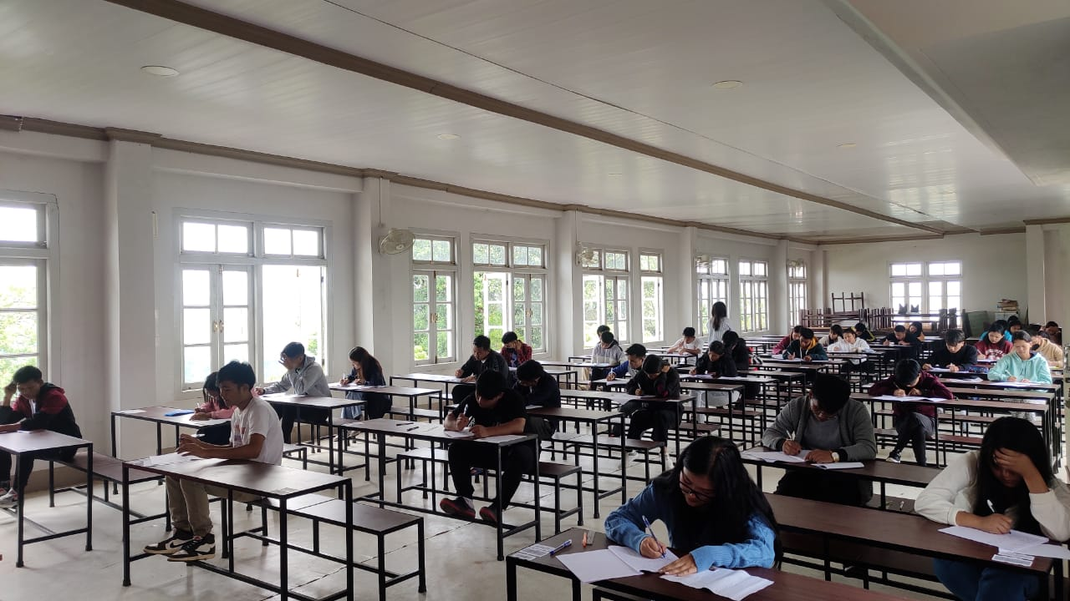
2 | Classrooms equipped with projector and WIFI accessibility | 7 | Of the classrooms of the college, 7 classrooms (which are core classrooms for the 7 different departments) besides having the common infrastructure of all the classrooms of the college are specifically equipped with overhead projectors (EPSON) and WIFI accessibility for classroom presentation and other IT based learning activities. | 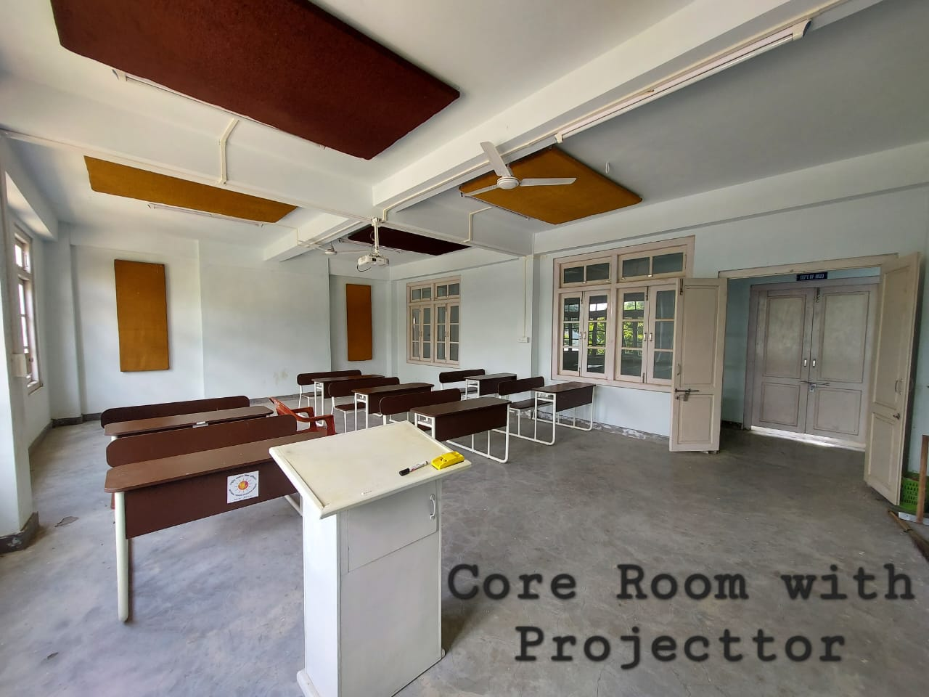
3 | Laboratories | 2 | There are 2 laboratories in the college which are respectively Geography laboratory and Language laboratory, each equipped with their own number of computers as follows :  - Geography Lab – 4 desktop computers  - Language lab – 11 desktop computers | 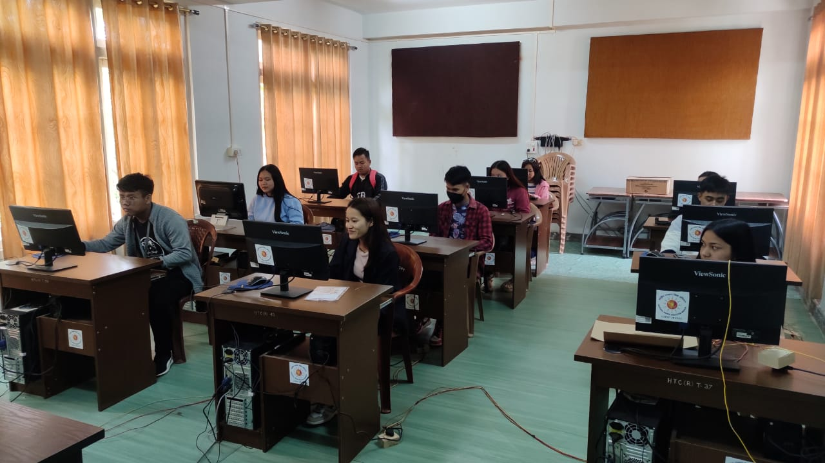  Language Laboratory  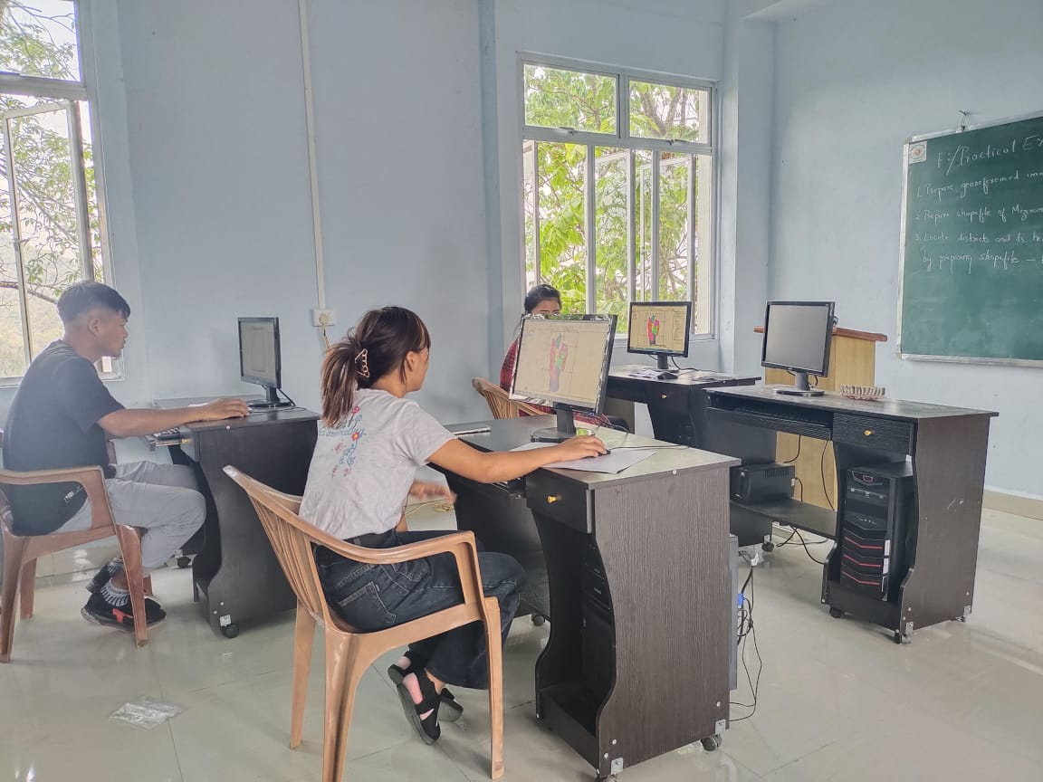  Geography Laboratory
4 | Library | 1 | There is a library in the college which is shared by all the departments which have their own separate book sections within the library itself. The library is also fully equipped with a reading room, research room, WIFI access and 1 desktop computer for visitor (college staff and student) use, and 4 desktop computers for the library staff. | 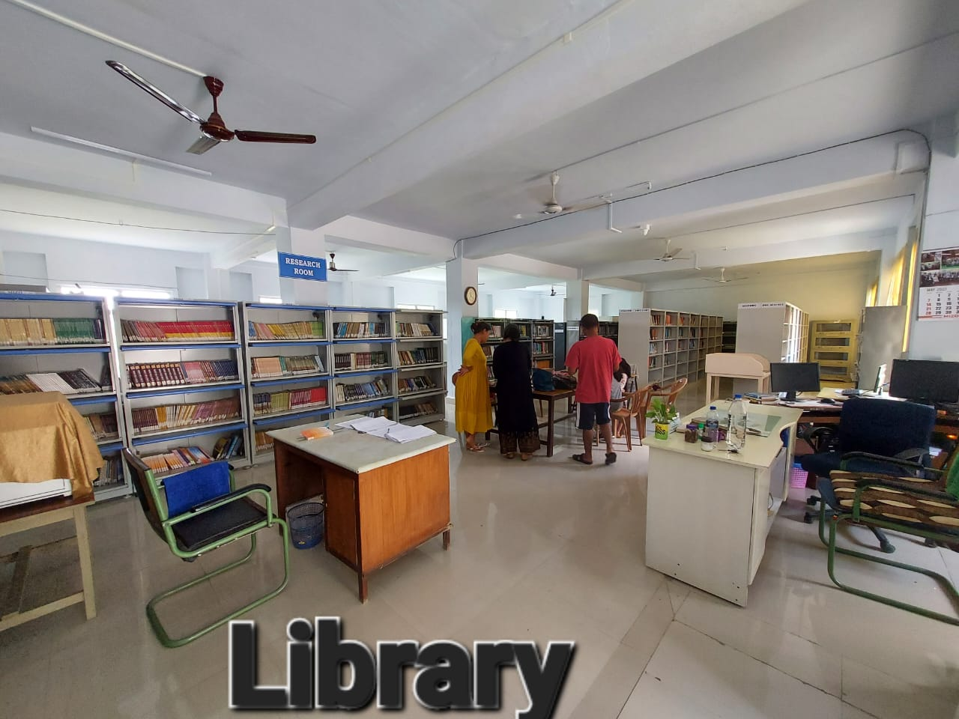  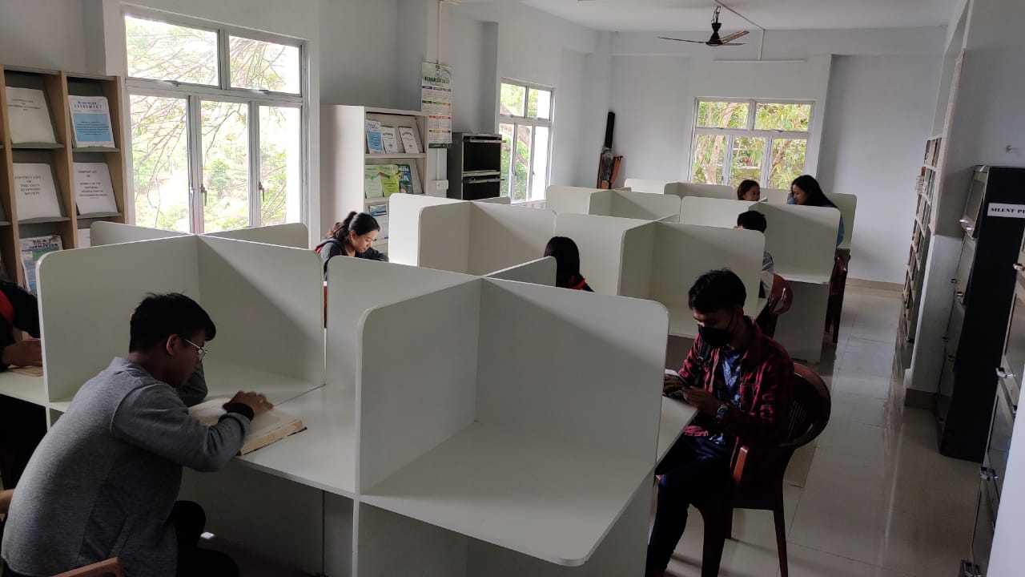  Reading room
5 | NEILIT study center (Computer center) | 1 | There is a computer center in the College spearheaded under NEILIT for IT learning . It is equipped with a total number of 20 desktop computers for student and faculty use to provide further proficiency in computer application. | 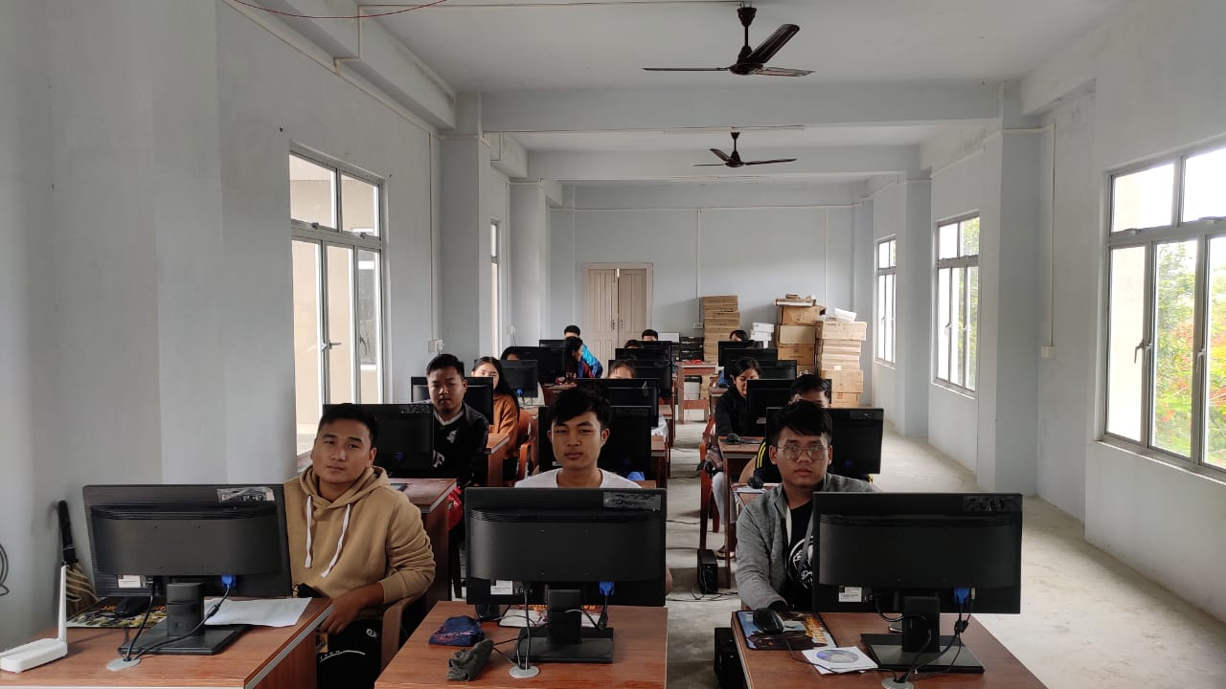
6 | CCTVs |  | One (1) CCTv surveillance system is installed having 16 channels distributed all around the campus for better security of the college infrastructure . | 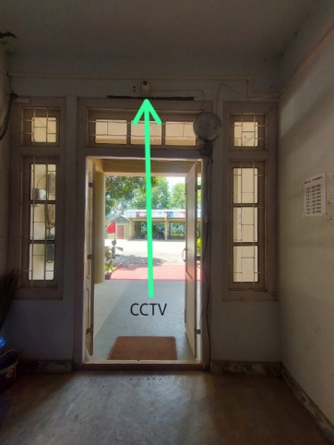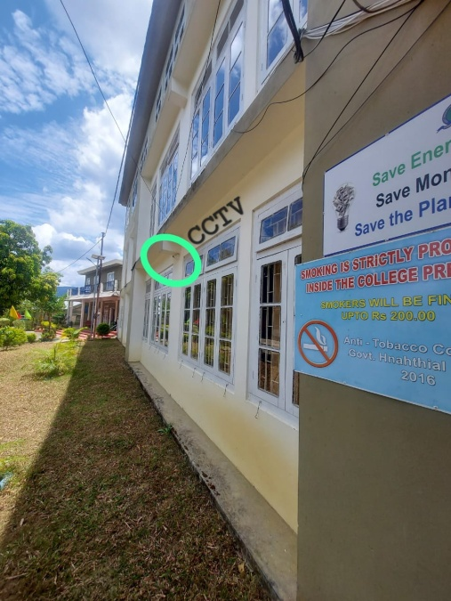
7 | Generator for power supply | 1 | There is a generator KOEL (GENSET MODEL/kVA KG1-15ASI/15KVA(IPM) installed in the campus to provide sufficient power for all the electricity based infrastructure whenever needed. | 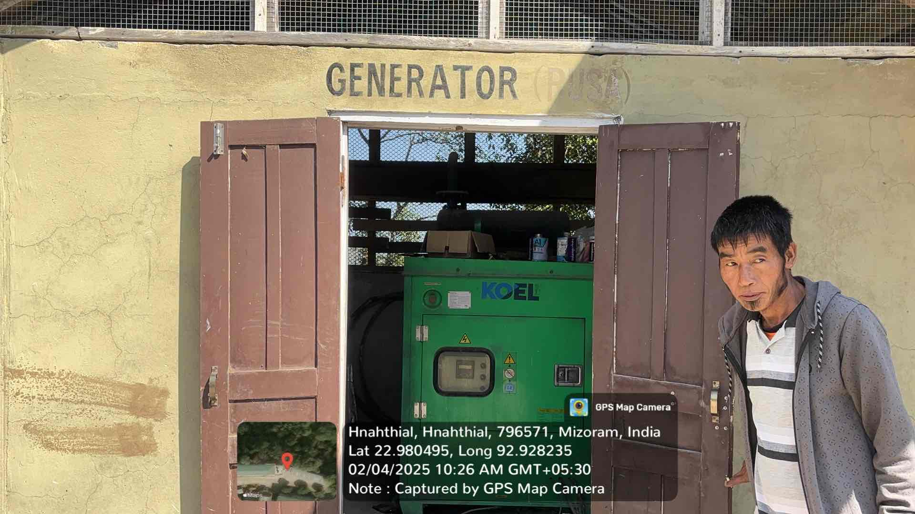
8 | Computers |  | All the computers of the college are distributed throughout the college buildings to perform different functions in providing learning, imparting course-based or general knowledge for all users (staff and students) and to provide administrative functions for the entire college.  Total number of desktop computers - 45 | 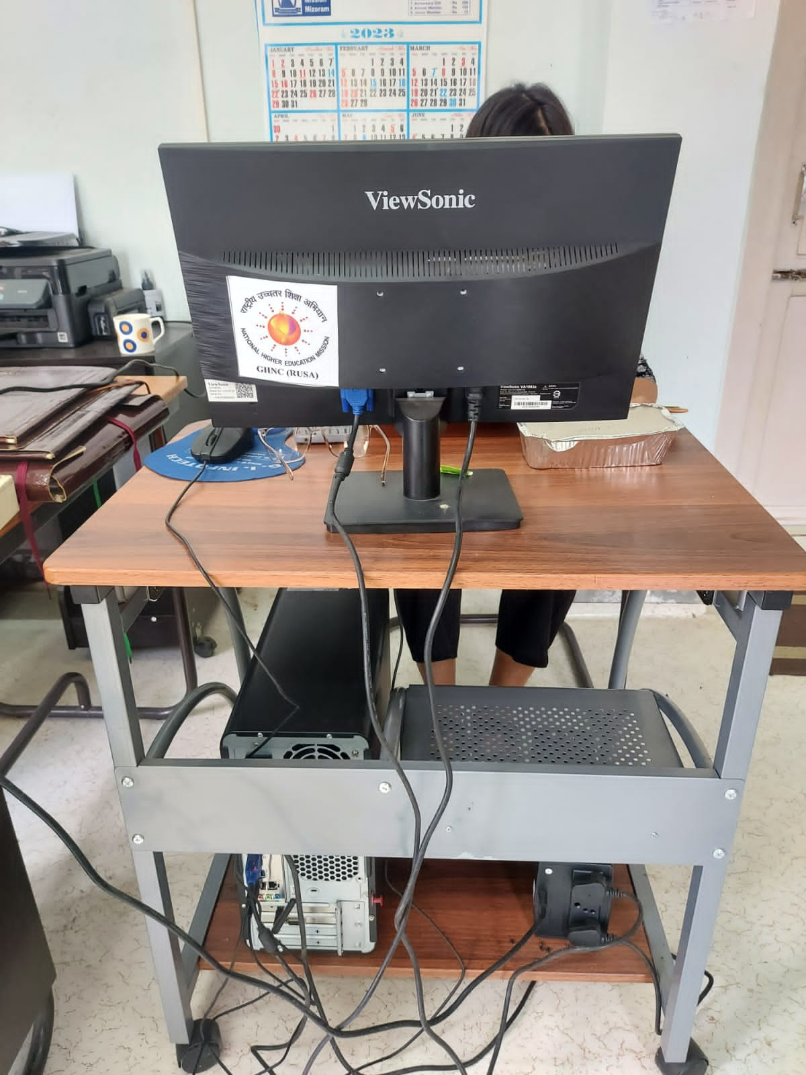
9 | Printers and photocopiers |  | The college is equipped with printers and photocopiers distributed into various buildings both accessible to staff as well as students.  Total no. of printers and photocopiers - 11 | 